BUSINESS PROCESS DOCUMENT
Shopee E-commerce System Development

Version 1.0 | 13/04/2026 | Product Development Department

Field | Details | Version | Date
Project Name | Shopee E-commerce System Development | 1.0 | 13/04/2026
Document Title | Business Process Document | 1.0 | 13/04/2026
Prepared By | - Azzahra Puteri Kamilah  - Marsha Aulia Rizky  - Marchella Keira Sambuaga  - Fatwa Putri Jingga  - Syakira Lathifa Awliya | 1.0 | 13/04/2026
Reviewed By | Fasya Nabila Salim | 1.0 | 13/04/2026
Approved By | Fasya Nabila Salim | 1.0 | 13/04/2026
Department | Product Development Department | 1.0 | 13/04/2026
Status | Draft | 1.0 | 13/04/2026

Table of Contents

Table of Contents 2
I. Introduction 3
1.1 Purpose 3
1.2 Scope 3
1.3 Objectives 4
1.4 Assumptions & Constraints 4
1.5 References 4
II. Process Overview 5
2.1 Process Summary 5
2.2 Process Boundaries 5
III. As-Is Process (Current State) 6
3.1 Description 6
3.2 As-Is Process Steps 6
3.2.1 Use Case Diagram 6
3.2.2 Flowchart/Swimlane Diagram 7
3.3 Pain Points & Issues 7
IV. To-Be Process (Future State) 8
4.1 Description 8
4.2 To-Be Process Flow 8
4.2.1 Use Case Diagram 8
4.2.2 Flowchart/Swimlane Diagram 9
4.3 Improvements Over As-Is 9
V. Roles & Responsibilities 10

I. Introduction

1.1 Purpose

This document aims to define and analyze the business processes of the Shopee e-commerce system. It focuses on understanding the current business process (AS-IS) and designing an improved future process (TO-BE) for key features such as Sign Up, Login, Product Search & Filtering, Shopping Cart & Checkout, Payment System, Order Tracking, and Rating & Review.

This document is created to address the need for a more integrated and efficient online shopping experience. Based on the project background, many existing platforms still rely on fragmented processes that do not provide a seamless end-to-end transaction flow. Therefore, this document identifies gaps and inefficiencies in the current process and proposes improvements to enhance system performance, user experience, and operational efficiency. It also serves as a foundation for further system design, development, and testing activities.

1.2 Scope

This business process document covers the analysis and design of core functionalities within an e-commerce platform based on the defined project scope.

In Scope:
- User registration (Sign Up)
- User authentication (Login)
- Product search and filtering
- Shopping cart and checkout process
- Payment processing
- Order tracking
- Rating and review system

Out of Scope:
- Seller management system (e.g., seller dashboard, inventory management)
- Advanced recommendation system (AI-based suggestions)
- Promotional features (e.g., flash sale, live shopping)
- Internal logistics management system
- User interface (UI/UX) design and detailed backend implementation

1.3 Objectives

- Clearly define and document the end-to-end business processes of the selected e-commerce features
- Identify gaps and inefficiencies between the current (AS-IS) and the desired (TO-BE) processes
- Propose improvements to enhance system efficiency, accuracy, and user experience
- Establish a baseline for system design, development, and testing activities
- Support the development of system blueprints such as use case diagrams and process flow diagrams

1.4 Assumptions & Constraints

Assumptions:
- Users have access to a stable internet connection
- Users access the system via mobile or web platforms
- Users are able to understand basic application navigation
- The system uses a centralized database to store user, product, and transaction data
- Product data (name, price, stock) is already available in the system
- Sellers have already listed products in the platform
- The system can integrate with external payment gateways for transaction processing
- The system can integrate with logistics services for order tracking
- Third-party services (payment and delivery) are available and functioning properly
- All transactions are recorded and stored securely

Constraints:
- The system is developed from scratch with no existing codebase
- The project timeline is limited (approximately 5–6 weeks)
- The scope is limited to selected core features only
- The project is handled by a small team (5 members)
- No budget is allocated for licensed tools; only free or open-source tools are used
- UI/UX design is based on existing application references (screenshots)

1.5 References

- Pre-Meeting Notes: E-Commerce System Development (Shopee)
- ISPM Course Materials and Lecture Slides
- Business Process Modeling Standards (Use Case Diagram and Flowchart)

II. Process Overview

2.1 Process Summary

The business process of the Shopee e-commerce system begins when a user accesses the platform to browse or purchase products. The system facilitates a series of core activities, including user authentication, product exploration, order placement, payment processing, and order fulfillment.

Throughout the process, the system interacts with external services such as payment gateways and logistics providers to ensure smooth transaction processing and delivery.

The process concludes when the transaction is completed, the product is successfully delivered to the user, and the user has the option to provide feedback through ratings and reviews.

2.2 Process Boundaries

Boundary | Description
Start Event | The process starts when the user accesses the system and performs an action such as registering a new account, logging in, or browsing products.
End Event | The process ends when the order has been successfully delivered to the user and the transaction is completed, including the option for the user to submit a rating and review.
Out of Scope | - Managing product inventory and stock updates by sellers  - Creating and managing product listings by sellers  - Handling promotional activities such as discounts, vouchers, and flash sales  - Managing customer service interactions such as chat or complaint handling  - Internal logistics operations such as warehouse management and delivery routing  - Technical implementation details, including UI/UX design and system development

III. As-Is Process (Current State)

3.1 Description
Before the Shopee platform existed, the online buying and selling process was conducted manually and relied heavily on direct communication between buyers and sellers through fragmented channels such as social media, messaging apps, or personal online storefronts. There was no centralized system to manage product discovery, transactions, or order fulfillment.
Customers would browse available products independently, then directly contact the seller to place an order. Payment was processed manually through bank transfers, after which the customer was required to send proof of payment to the seller for verification. Once the seller confirmed the payment, they would proceed to manage and fulfill the order, including coordinating shipment through a third-party logistics service. Order tracking was not automated, customers had to manually request order status updates from the seller. Feedback was given informally, with no structured review or rating system in place.
This process was time-consuming, error-prone, and heavily dependent on human coordination at every step, creating significant inefficiencies for both buyers and sellers.

3.2 As-Is Process Steps

3.2.1 Use Case Diagram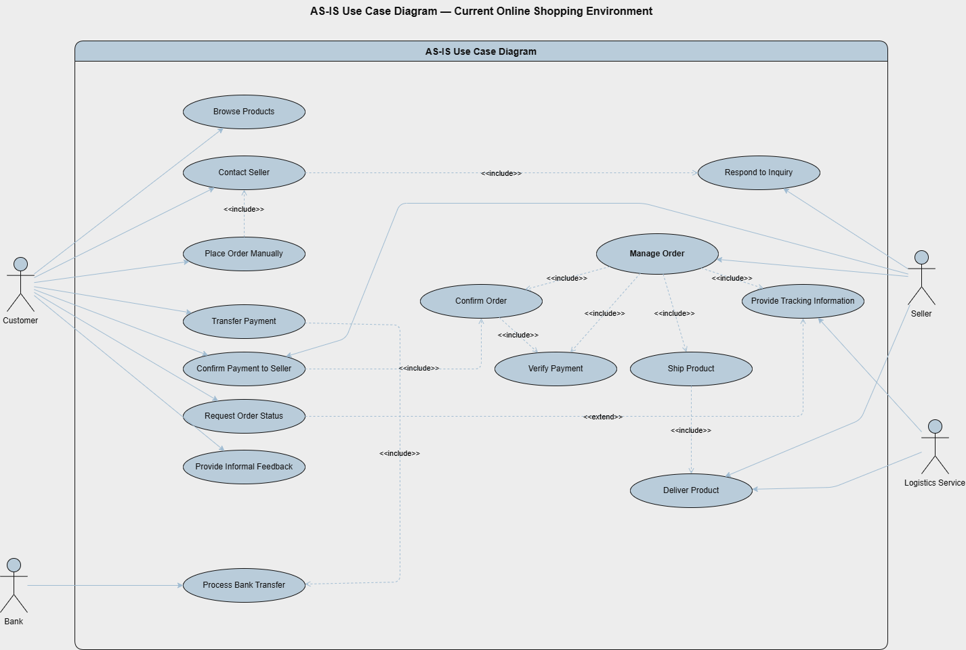

3.2.2 Flowchart/Swimlane Diagram
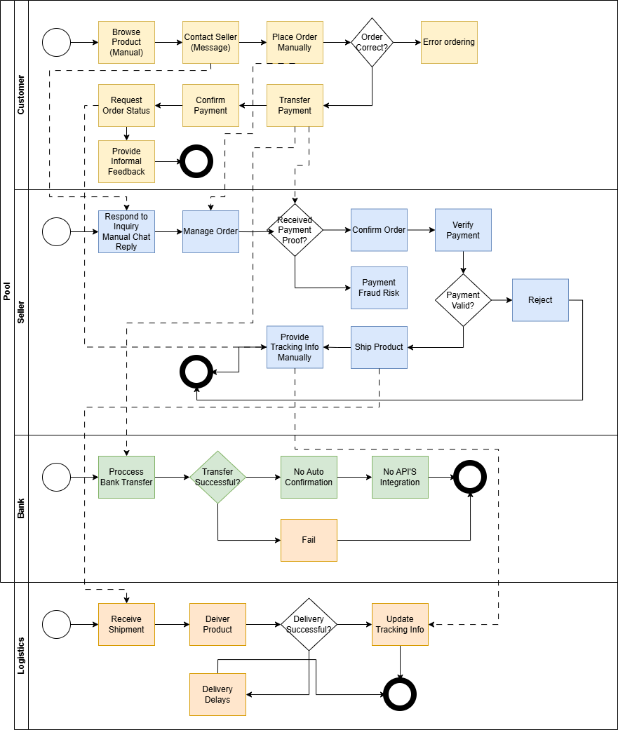

3.3 Pain Points & Issues
- No product search & filter, customers browse manually with no category or price filter
- No shopping cart, orders are placed manually via chat, highly error-prone
- Manual payment confirmation, customers send screenshot; high risk of fraud
- No payment gateway integration, bank transfer is fully external with no auto-confirmation
- No order tracking system, customers must ask the seller manually for order status
- No real-time logistics tracking, logistics updates are manual, causing delays
- No review system, feedback is informal (chat/social media), not visible to other buyers
- No seller dashboard, very high manual workload for managing orders and inquiries

IV. To-Be Process (Future State)

4.1 Description
The To-Be process describes how the system will operate after the e-commerce platform is implemented. Users can easily search for products, add items to the cart, and complete purchases through an integrated system. The platform also supports secure payment methods, real-time order tracking, and a rating & review feature. This system improves efficiency, reduces manual processes, and provides a better user experience.

4.2 To-Be Process Flow

4.2.1 Use Case Diagram

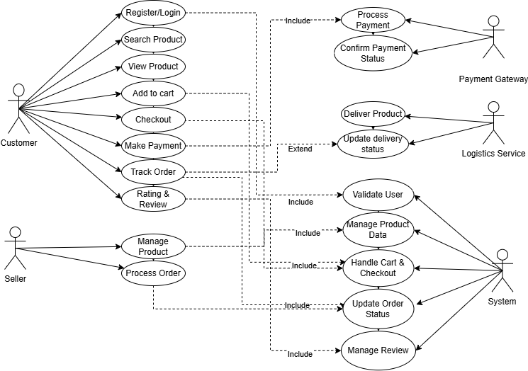

4.2.2 Flowchart/Swimlane Diagram
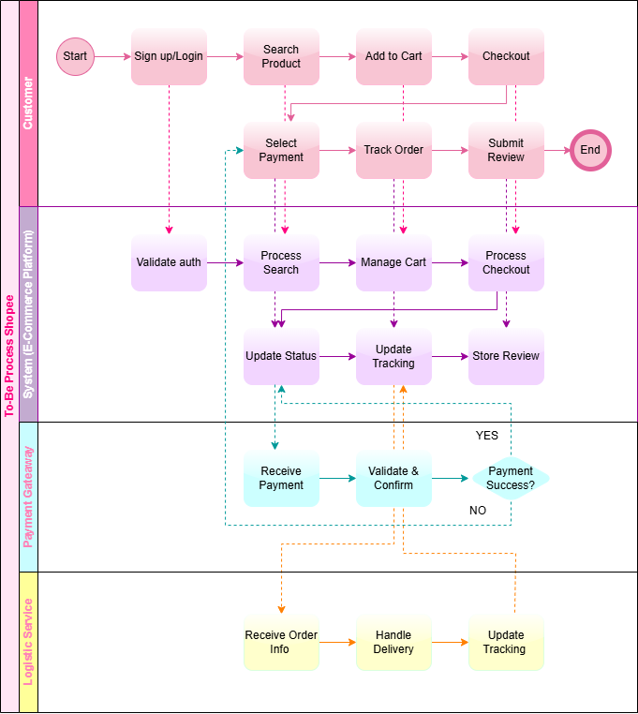

4.3 Improvements Over As-Is
- Automated product search and filtering replaces manual browsing across multiple platforms, resulting in faster and more accurate product discovery for users.
- Integrated cart and checkout system eliminates miscommunication from chat-based ordering, reducing human error and providing structured order management.
- Automated payment gateway integration replaces manual bank transfer verification, enabling faster, more secure, and fully traceable transactions within 5 seconds.
- Real-time order tracking system replaces manual status inquiries to sellers or couriers, providing full visibility and transparency for buyers throughout the delivery process.
- Integrated rating and review system replaces informal feedback shared outside the platform, increasing buyer trust and platform credibility.
- Single integrated e-commerce platform replaces fragmented buying and selling across multiple apps, delivering a seamless and consistent end-to-end shopping experience.

V. Roles & Responsibilities

Role/Actor | Department | Responsibilities | System Access Level
Customer (User) | Customer | Register account, login, search and filter products, add items to cart, perform checkout, make payments, track orders, and provide ratings & reviews | User
System | System | Handle data processing, validate user input, manage transactions, update order status, and integrate with external services such as payment gateway and logistics | Admin
Payment Gateway | External Service | Process payment transactions, verify payment status, and send confirmation to the system | Admin
Logistics Service | External Service | Handle order shipment, update delivery status, and provide tracking information | Admin
Admin | Operations | Monitor system activities, manage transaction data, ensure system performance, and handle issue resolution | Admin

